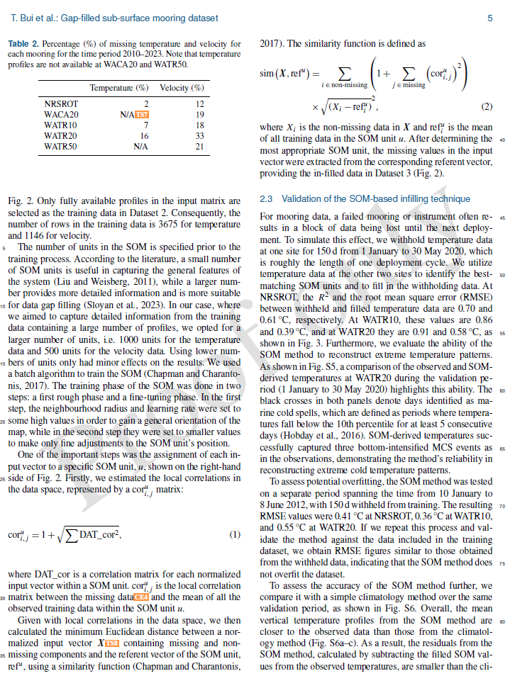

To avoid confusion for readers, we decide to remove Equation 1 and modify the sentences related to its description. The affected lines are highlighted in red below.
“One of the important steps was the assignment of each input vector to a specific SOM unit, u, shown on the right-hand side of Figure 2. Firstly, we estimated the local correlations in the data space, represented by a ${cor}_{i,j}^{u}$ matrix.
${cor}_{i,j}^{u}$=1+$\sqrt{\sum{{DAT_cor}^{2}}}$, | (1)
Where DAT_cor is a correlation matrix among each normalized input vectors within a SOM unit; ${cor}_{i,j}^{u}$ is the local correlation matrix between the missing and the mean of all the observed training data within the SOM unit u.
Given with local correlations in the data space, we then calculated the minimum Euclidean distance between a normalized input vector $X$ containing missing and non-missing components and the referent vector of the SOM unit, ${ref}^{u}$ using a similarity function (Chapman and Charantonis, 2017). The similarity function is defined as:
$$sim\left(X,{ref}^{u}\right)=\sum_{i∈non-missing}{\left(1+\sum_{j∈missing}{{\left({cor}_{i,j}^{u}\right)}^{2}}\right)}×\sqrt{{(X_{i}-{ref}_{i}^{u})}^{2}},$$ | (2)
Where $X_{i}$ is the non-missing data in $X$, ${ref}_{i}^{u}$ is the mean of all training data in the SOM unit u”

The combined paragraph is to be revised as (changed text in blue):
“One of the important steps was the assignment of each input vector to a specific SOM unit, u, shown on the right-hand side of Figure 2. To do this, we calculated the minimum Euclidean distance between a normalized input vector $X$ containing missing and non-missing components and the referent vector of the SOM unit, ${ref}^{u}$ using a similarity function (Chapman and Charantonis, 2017). The similarity function is defined as:
$$sim\left(X,{ref}^{u}\right)=\sum_{i∈non-missing}{\left(1+\sum_{j∈missing}{{\left({cor}_{i,j}^{u}\right)}^{2}}\right)}×\sqrt{{(X_{i}-{ref}_{i}^{u})}^{2}},$$ | (1)
Where $X_{i}$ is the non-missing data in $X$, ${ref}_{i}^{u}$ is the mean of all training data in the SOM unit u, and ${cor}_{i,j}^{u}$ is the local correlation matrix between the missing variables and available variables over all the observed training data within the SOM unit u.”

