The requested changes are as follows:

Page 13, Table 2:
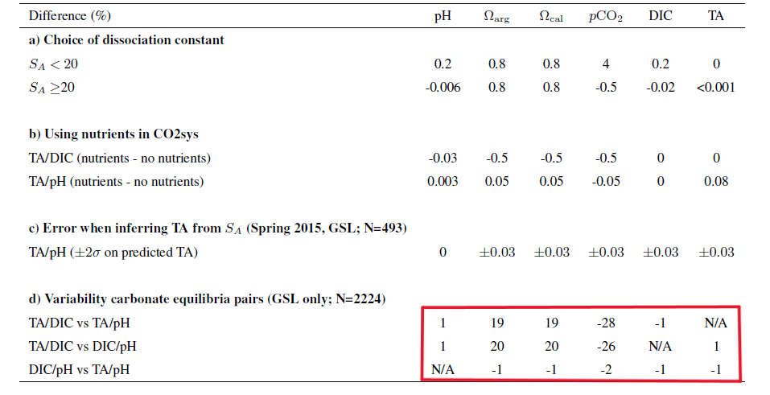
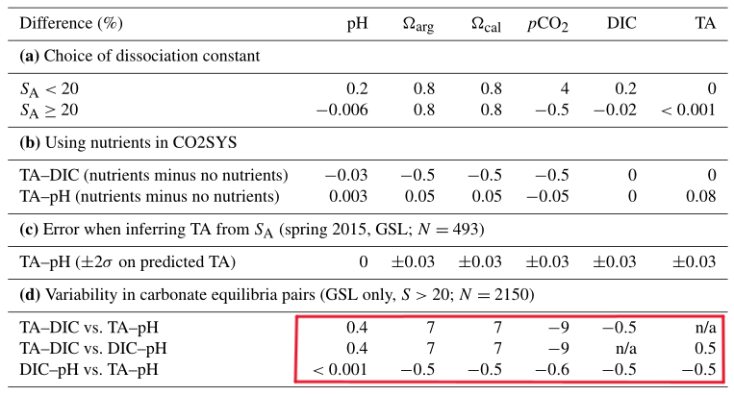
The values in the columns marked by the red square should be changed into the current numbers:

Explanation: Values in the Table 2d have changed after the discovery of a coding error. The variability is now much smaller than previously calculated (see original table in the email)

