The requested changes are as follows:

Page 13, Figure 12:

Replace the current Fig. 12 by the new one:
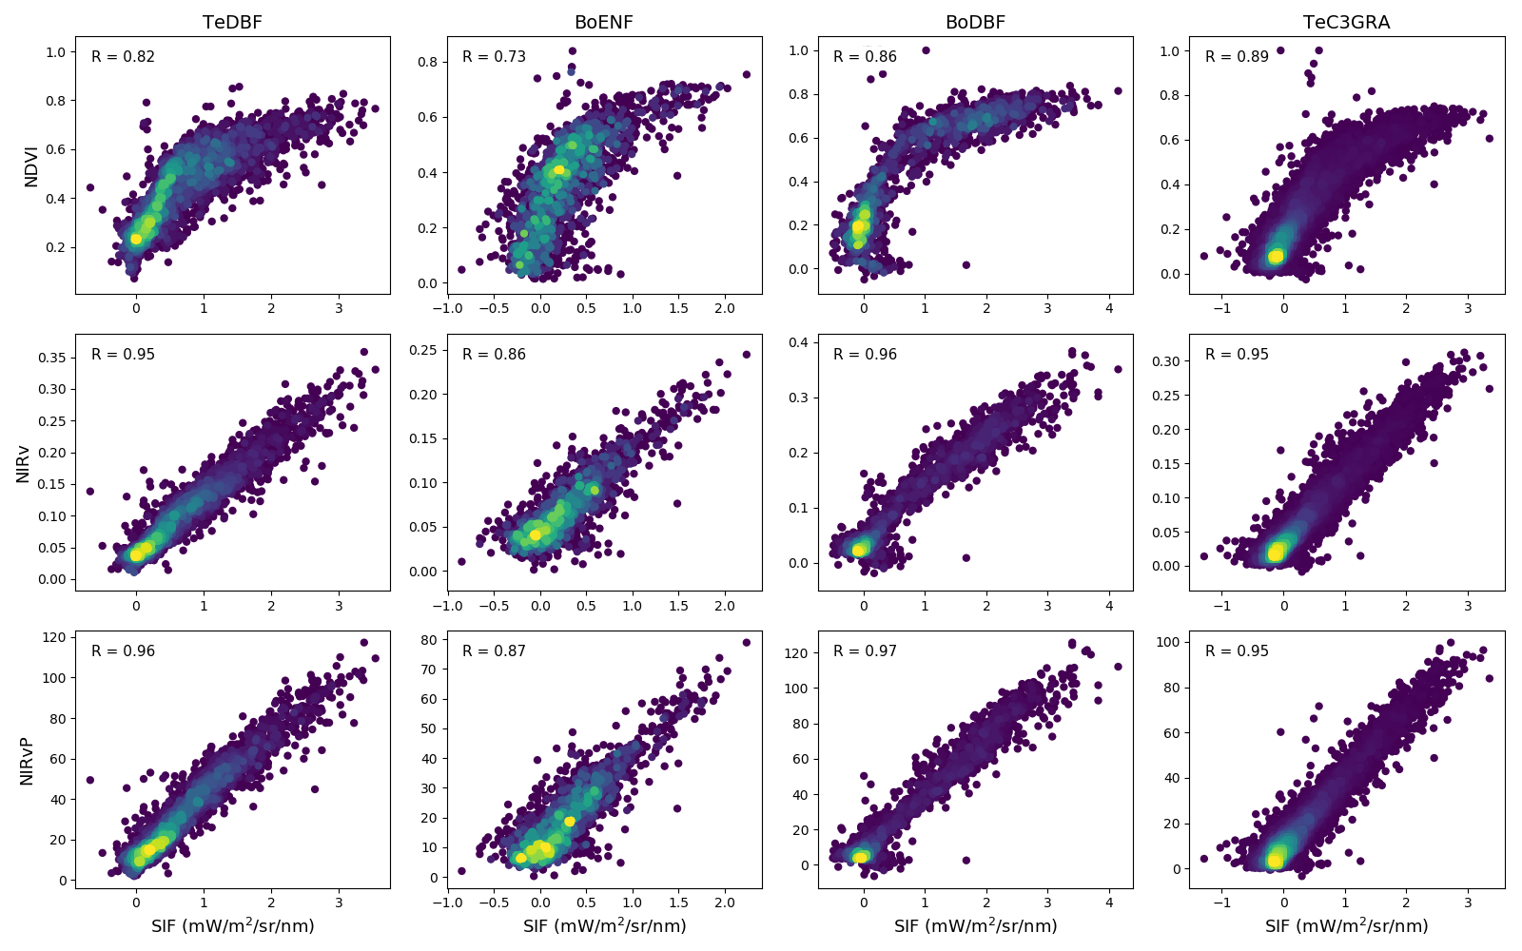

Page 13, lines 7-8:

Change "a slightly more linear relationship" in p13, L7 to "a similar linear relationship"

