Dear Editor,

I am Peiyu Cao. I am writing this letter to request four minor changes for our manuscript entitled “Historical nitrogen fertilizer use in agricultural ecosystems of the contiguous United States during 1850-2015: application rate, timing, and fertilizer types”, which is under the proofreading status. Here are the details:
1) Replaced “years between 1850 to 1930” with “missing data years” in the explanation of equation (1) in page 4 (section 2.1.3). This change is needed as Eq. (1) was also used at another section (2.1.4) and was applied to another period (1850-1953).
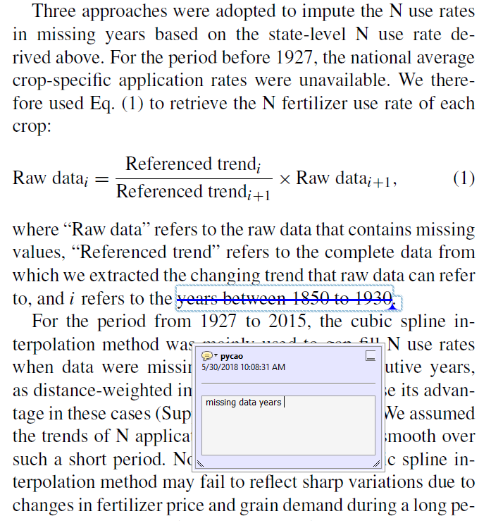

2) Replaced “1900” with “the 1940s” in page 7 and page 13 (Conclusion). This correction is needed as the pattern of hotspot shifted is clear from 1940 to 2015 rather than from 1900.
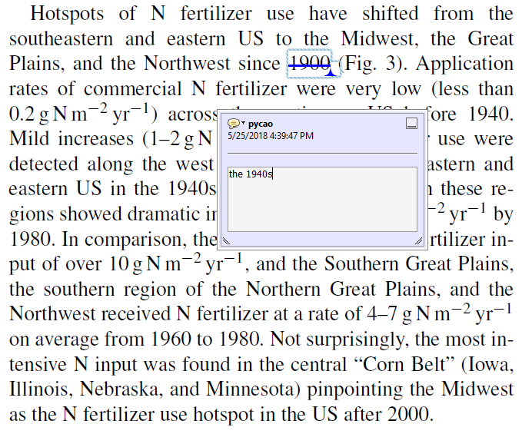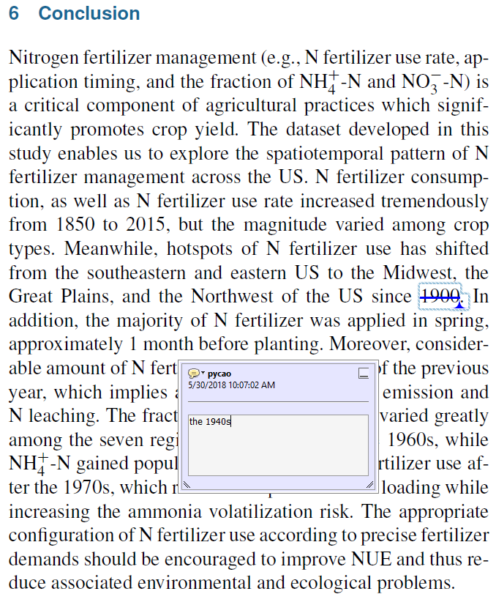
3) Replaced “western” with “eastern” in section 3.2 in page 7. This correction is needed as seen from Fig. 4(d), in which we found the intensive N use after planting was in the east of the Midwest rather than in the west of this region.
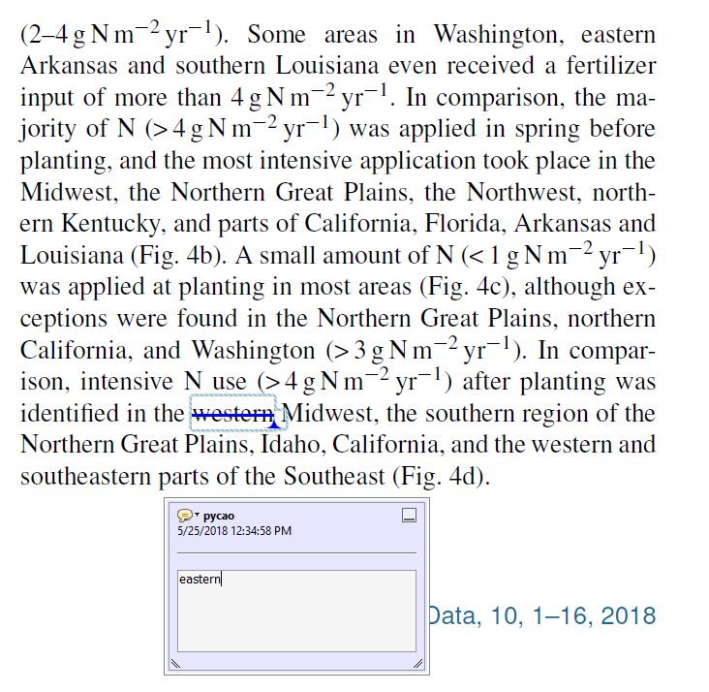

We apologize for the mistakes made. Thank you for your helps.

Sincerely,
Peiyu

